Particles & Interactions
Document Overview:
This activity serves multiple purposes. One purpose of this activity is to show students that momentum, energy, charge, and lepton number are conserved. Students can use bar-graphs for scalar values and arrows for vector values. Another purpose is to introduce the concept of fundamental particles. A third purpose is to introduce the idea of relativistic mass and E=mc².

Minnesota State Academic Science Standards:
- Understanding in science changes. Particles once thought to be fundamental have been found to not be fundamental.
- Conservation of Energy
- Conservation of Charge
- Conservation of Momentum
- Relativity E = mc²
- 9.1.1.2.3 Identify the critical assumptions and logic used in a line of reasoning
- 9.1.3.4.3 Select and use appropriate numeric, symbolic, pictorial, or graphical representation to communicate scientific ideas, procedures and experimental results.

Objective:
Students will draw vector arrows to represent momentum to solve conservation of momentum problems.
Students will use bar charts to solve problems dealing with conservation of charge, energy, and lepton number.
Students will describe the materials each substance is composed of, in order to lead them to the idea that some particles are fundamental.

Type of Activity:
Worksheet that can be done in groups or individually.
Duration:
The worksheet could take between 1 & 2 class periods, depending on how the depth the instructor chooses.

Connection to Nobel speakers:
Wilczek: The worksheet eventually gets to the analysis of interactions between particles present in the standard model (muons, neutrinos, quarks etc...)
Shears:One method to create a Higgs boson is represented for students to work through.
Gates: Gates work deals with the standard Model. This sheet uses particles in the Standard Model and relates conservation rules that govern particle interaction and production.
Ting: Ting's work in the 1970's was in elementary particle detection. This sheet may familiarize students with aspects of particle generation. As an extension, the teacher could lead students through detection methods.
Krauss: If Krauss talks about dark energy, he may relate mass to energy. This sheet introduces E = mc² that Krauss would likely reference.

Teacher Tips:
The use of bar charts to represent conserved values is a non-intimidating way to develop the idea of conservation. Generally, we want the total initial value to equal the total final value. In most of these cases, there aren't any charges, energies, or momentum being introduced from outside of the system being analyzed. Since the system is closed, the initial and final values should total to a value that does not change.
Using arrows to represent momentum values can help students to see that both the magnitude of the momentum (the length of the momentum arrow) and the direction of momentum (the direction the momentum arrow points) are conserved.
You could choose to skip a few interactions. The activity is designed to start with some interactions that may be familiar or conceivable to students and build to more unique interactions.
Photons: Photons are mentioned as small particles of light. You could choose to go deeper into the idea of photons here, or that could wait until later in the year.
Fundamental Particles: The sheet references muons, electrons, positrons, neutrinos etc... The particles listed on the standard model chart are fundamental. It is currently thought that these particles are fundamental. That means these fundamental particles don't have any smaller parts, they are indivisible.
Currently, the Higgs boson might be fundamental. Scientists know that it is possible that it may have inner parts that we simply can't see with current colliders / microscopes. The same may be true for quarks, fermions and other bosons. They are currently thought to be fundamental, but scientists understand that future colliders or microscopes may change this theory.
Kids might be familiar with the idea that a nuclear bomb releases a lot of energy. They might also (might) know that this comes from the complete destruction of mass by Einsteins E=mcc. Remind them that the energy that is produced from this erasure of mass is just energy. The mass that was destroyed or erased doesn't leave any smoke, dust, charred embers. If we witness any smoke, dust, or charred embers they were created when the released energy meets other objects.
Making particles is a bit like the reverse of a nuclear bomb (my analogy, and it may have plenty of holes). Instead of erasing mass and making energy, the process goes backwards. A collision of two particles (maybe a positron and an electron, or perhaps two quarks, or a quark and a gluon) has a certain amount of energy. The particles have mass and velocity and therefore have energy. The energy of the collision can actually MAKE NEW MATTER. This isn't simply the rearranging of particles that were already present.
There are multiple ways these collisions are designed. Method 1: accelerate a positron in one accelerator and an electron in another. Get them going fast enough so they have enough energy to make what you are looking for. Point them at each other. If they collide with 150 GeV of energy, they make particles with that much energy. That might be a Higgs boson and a couple of high energy photons. Method 2: accelerate a couple of protons at each other (or perhaps a proton and an antiproton). Each proton contains what averages out to be 2 up quarks and 1 down quark. Each proton also has Gluons that hold the protons together. Accelerate a bunch of protons at each other at more than the 150 GeV. Each proton that collides brings with it at least 3 quarks and some gluons. If there is a collision, it might be 1 quark hitting another, it might be one gluon hitting another, it might be a quark hitting a gluon, and so on. A bunch of particles can be produced. In this case, there may be a bunch of data that needs to be filtered to find the right bit of data that shows the particle you were looking for was actually present. If you have a positron collide with an electron, there is a bit less filtering necessary, but you also have a lower rate of successful collisions.

Concepts:
Addressed in Teacher Tips.

Description of Activity:
Students use conservation of energy, charge, and momentum to analyze scenarios. Students start with scenarios that might be more familiar (carts and billiard balls colliding). They then use the exact same rules to analyze some high energy physics scenarios.

Materials:
Printed paper.
It would be nice to have a table of the Standard Model as students progress through the activity.
Activity:
The worksheet should be done in small groups.
Extension and Follow-up Activity:
Numbers can be added to each problem to allow a follow up activity that includes calculations. Check back later, and appropriate numerical values might be available.
Source:
Electronic communication with John Denker, Moses Fayngold, Bill Nettles, Daniel Schroeder, Bruce Sherwood, on 6-17-13 and 6-18-13.
Personal communication with Kirsten A. Tollefson on 6-19-13.
Electronic communication with Tara Shears on 6-17-13.
Mass values reference from Wikipedia 6-19-13.

Particles & Interactions Name Period 1 2 3 4 5 6 7 Date

Interaction #1: Two Carts Collide #1
One cart is moving to the right while one cart is stationary. The moving cart hits the second cart. After the interaction, the second cart moves to the right while the first cart is stationary.

Materials:
As specifically as possible, state the types of materials that might be used to make the objects before and after the collision.
Particles before the interaction: Particles after the interaction:
Sample metal atoms (maybe aluminum?), the same
Answer molecules of plastic (i don't know the type) the same
maybe some oil in with the bearings the same

Momentum:
The pre-interaction momentum of each object in the system is show using both numbers and arrows. The sign of the number tells us the direction of the momentum. The number itself tells us the amount of momentum. The arrow also tells us about the momentum of each object. The size of the arrow conveys how much momentum. The direction the arrow points tells us the direction of the momentum of that object. Both the total amount of momentum, and the direction of momentum must remain conserved for all systems everywhere in the universe.
Recall that throughout the universe, momentum must always be conserved. Using this rule, draw in: a) the missing values for momentum in the post-interaction image, b) the missing momentum arrow below the image of the interaction, and c) an arrow that represents the total momentum of system of objects after the interaction.
Cart 1
Cart 2
p=+4
p=0
Cart 1
p = 0
p=____
Cart 2
Pre-Interaction
Post-Interaction
=
p_{initial-1 +} P_{initial 2 =}=+4
p_{final-1} + P_{final 2 =}=+4


Energy:
The total energy for the system of objects must remain constant for the interaction above. Imagine the carts have very good bumpers (perhaps really strong magnets) that allow the interaction to work really well.
Complete the post-interaction bar chart so that it both conserves energy, and accurately reflects the velocity of the carts.
E_{k cart 1} E_{k Cart 2}
Amount of Energy
Amount of Energy
E_{k cart 1} E_{k Cart 2}

Charge
The total charge must also be conserved for the interaction. Each cart has an almost unfathomable number of electrons (-1) and protons (+1). The total charge for each cart would typically add to something close to zero.
In this interaction, cart 1 had a small initial positive charge and cart two had a small initial negative charge. Add the correct bars for the carts, post-interaction, so that total charge is conserved.
Amount of Charge
Amount of Charge
Cart 1 Cart 2
Cart 1 Cart 2

Interaction #2: Carts Collide #2
One cart is moving toward the right (the positive direction) and hits a second cart that is initially at rest. After the interaction, both carts are moving to the right.

Materials:
As specifically as possible, state the types of materials that might be used to make the objects before and after the collision.
Particles before the interaction: Particles after the interaction:

Momentum:
Recall that throughout the universe, momentum must always be conserved. Using this rule, draw in: a) the missing values for momentum in the post-interaction image, b) the missing momentum arrow below the image of the interaction, and c) an arrow that represents the total momentum of system of objects after the interaction.
Cart 1
Cart 1
Cart 2
p_{1i}=+4
p=0
p = +1
p=_________
Cart 2
Pre-Interaction
Post-Interaction
=
p_{initial-1 +} P_{initial 2 =}=+4
p_{final-1} + P_{final 2 =}=+4

Energy:
Complete the post-interaction bar chart so that it both conserves energy, and accurately reflects the velocity of the carts.
E_{k cart 1} E_{k Cart 2}
Amount of Energy
Amount of Energy
E_{k cart 1} E_{k Cart 2}

Charge
The total charge must also be conserved for the interaction. Each cart has an almost unfathomable number of electrons (-1) and protons (+1). The total charge for each cart would typically add to something close to zero.
In this interaction, cart 1 had a small initial positive charge and cart two had a small initial negative charge. Add the correct bar for cart 2, post-interaction, so that total charge is conserved.
Amount of Charge
Amount of Charge
Cart 1 Cart 2
Cart 1 Cart 2

Interaction #3: Billiard Balls Collide
Two billiard balls collide. They do not hit directly head on. After the interaction, the cue ball goes to the right and down while the 8 ball goes to the right and up.

Materials:
As specifically as possible, state the types of materials that might be used to make the objects before and after the collision.
Particles before the interaction: Particles after the interaction:

Momentum:
Recall that throughout the universe, momentum must always be conserved. Using this rule, draw in: a) the missing values for momentum in the post-interaction image, b) the missing momentum arrow below the image of the interaction, and c) an arrow that represents the total momentum of system of objects after the interaction.
p_{final-1} + P_{final 2 =}=+4
p_{initial-1} + P_{initial 2 =}=+4
p _{x} =+4
p _{y} = 0
p=0
p _{x}= +2
p _{y}=-2
Pre-Interaction
Post-Interaction
8
Cue Ball
p _{8x}= +2
p _{8y}= ____
8

Energy:
Recall that the universe conserves energy. Complete the post-interaction bar chart so that energy is conserved.
E_{k cue ball} E_{k 8 ball}
E_{k cue ball} E_{k 8 ball}

Amount of Energy
Amount of Energy
0

Charge
In this interaction, the cue ball has a small negative charge and the 8 ball has a small initial positive charge. Add the correct charge for the 8 ball, post-interaction, so that total charge is conserved.
Cue8 Ball
Ball
Amount of Charge
Amount of Charge
Cue8 Ball
Ball

Interaction #4: A photon of light collides with an electron
A photon (a particle of light) is moving toward the right (the positive direction) and hits an electron that is initially at rest. After the interaction, the photon moves to the right and upward while the electron moves to the right and downward. Both carts are moving to the right.

Materials:
As specifically as possible, state the types of materials that might be used to make the objects before and after the collision.
Particles before the interaction: Particles after the interaction:

Momentum:
Recall that throughout the universe, momentum must always be conserved. Using this rule, draw in: a) the missing values for momentum in the post-interaction image, b) the missing momentum arrow below the image of the interaction, and c) an arrow that represents the total momentum of system of objects after the interaction
Pre-Interaction
Post-Interaction
electron
incident photon
p _{photon} = +4
p _{electron} = 0
p _{x-photon} =+2
p _{y-photon} = +2

p _{x-electron} =_____
p _{y-electron} = _____

p_{final-1} + P_{final 2 =}=+4
p_{initial-1} + P_{initial 2 =}=+4

Energy:
Complete the post-interaction bar chart so that energy is conserved. The energy of the photons can be calculated by multiplying their frequency by something called Plank's Constant (E = hf).
Amount of Energy
Amount of Energy

0
E _{photonl} E_{electron}
E_{photon} E_{electron}

Charge
In this interaction, the electron has a charge of -1, and the photon (light particle) has no charge. Complete the charge bar graph below so it shows conservation of charge and accurately represents the charge of the particles present.
photon electron

Amount of Charge
Amount of Charge
photon electron

Interaction #5: Two high energy photons collide and produce an electron and a positron.
When two high energy photons collide (if they have enough energy) the photons stop existing. Instead, an electron and a positron are produced. A positron has the same mass as an electron, but has a positive charge.

Materials:
As specifically as possible, state the types of materials that might be used to make the objects before and after the collision.
Particles before the interaction: Particles after the interaction:

Momentum:
Recall that throughout the universe, momentum must always be conserved. Using this rule, draw in: a) the missing values for momentum in the post-interaction image, b) the missing momentum arrow below the image of the interaction, and c) an arrow that represents the total momentum of system of objects after the interaction
Pre-Interaction
Post-Interaction
p_{final-1} + P_{final 2 =}=
p_{initial-1} + P_{initial 2 =}=
p _{electron} = -2
p _{x-2 photon} =+2
p _{y-2 photon} = +2

p _{x-1 photon} =+2
p _{y-1 photon} = -2

p _{positron} = _____

Energy:
You might find the creation of particles to be a bit unique. The universe conserves energy.
Once we get to particles that have this small of a mass (photons do not have mass, and electrons have a mass of ~9 x 10 ⁻ ³¹ kg) scientists begin to describe the energy the particle has due to its mass. We consider energy and mass to be related by the relationship E = mc². If mass disappears, it becomes energy. If energy disappears, it forms mass. Energy and mass are considered to be equivalent. The energy of the photons can be calculated by multiplying their frequency by something called Plank's Constant (E = hf)
Not only will scientists use this 'rest mass energy' to describe the energy of particle, they will also use the rest mass energy to describe the mass of the particle, thinking of rest mass and rest mass energy as synonyms.
The bar chart below includes spots for moving energy, and rest energy (the E = mc² due to the mass of the particle) for each particle. Complete the post-interaction bar chart so that energy is conserved.
Complete the post-interaction bar chart so that energy is conserved.
E_{move} E_{rest} E_{move} E_{rest}
e⁺ e⁻

Photon 1 Photon 2
Amount of Energy
Amount of Energy

Charge
Photons (light 'particles') have no charge. Complete the charge bar graph below so it shows conservation of charge and accurately represents the charge of the particles present.
Photon 1 Photon 2

Amount of Charge
Amount of Charge
Electron Positron

0
0

Interaction #6: A muon decays into other particles.
A muon is thought to be a fundamental particle, meaning it doesn't have any structure. In other words, no parts are combined to make a muon. Neatly enough, a muon is not stable. It will decay to form other particles. The muon no longer exists. In one decay process for the muon's energy becomes an electron, an anti-electron neutrino, and a muon neutrino. We believe these other particles are also fundamental.
This can be written as:
μ⁻ → e⁻ + ν_{e} + ν_{μ}
muon → an electron & anti-electron neutrino & muon neutrino.

Materials:
As specifically as possible, state the types of materials that might be used to make the objects before and after the collision.
Particles before the interaction: Particles after the interaction:

Momentum:
Recall that throughout the universe, momentum must always be conserved. Using this rule, draw in: a) the missing values for momentum in the post-interaction image, b) the missing momentum arrow below the image of the interaction, and c) an arrow that represents the total momentum of system of objects after the interaction
p_{final-1} + P_{final 2 +} P_{final 3} =
p_{initial-1} = +4
Pre-Interaction
Post-Interaction
μ⁻
p=+4
ν_{μ}
ν_{e}
e⁻
p _{x-vu} =+1
p _{y-vu} = +1

p _{x-e} =____
p _{y-e} = ____

p _{x-ve} =+2

Energy:
Particles that have this small of a mass (μ⁻ have a mass of ~1.8 x 10 ⁻ ²⁸ kg) are often described by the energy the particle has due to its mass. We consider energy and mass to be related by the relationship E = mc². If mass disappears, it becomes energy. If energy disappears, it forms mass. Energy and mass are considered to be equivalent.
Not only will we use this 'rest mass energy' to describe the particle, they will also use the rest mass energy to describe the mass of the particle, thinking of rest mass and rest mass energy as synonyms.
The bar chart below includes spots for moving energy, and rest energy (the E = mc² due to the mass of the particle) for each particle. Complete the post-interaction bar chart so that energy is conserved.
Amount of Energy
Amount of Energy

E_{move} E_{rest}
Muon Muon

E_{move} E_{rest} E_{move} E_{rest} E_{move} E_{rest}
ν_{e} ν_{u} e⁻

Charge
When the muon decays, the charge must be conserved. Complete the charge bar chart in a manner that is consistent with both conservation of charge, and with what you know about the particles involved.
μ⁻
muon

Amount of Charge
Amount of Charge
ν_{e} ν_{u}e⁻

Lepton Number:
There are a few more values that the universe 'seems' to keep conserved. Lepton number is one of them. Each particle that is around the size of an atom has a Lepton number. Leptons have a value of +1, anti-leptons -1, and non-leptons 0. Complete the table below in a manner that is consistent with the universe's requirement to conserve lepton numbers.
μ⁻
muon

Lepton
Number
Lepton
Number
ν_{e} ν_{u}e⁻

Interaction #7: Electron - positron annihilation produce Higgs boson.
An electron and a positron (a positron is an anti-electron, or an anti-lepton) with large amounts of energy collide. They produce two high energy photons (in the gamma ray energy level) and a Higgs boson. The photons travel in opposite directions. We assume (for now) that the Higgs Boson is a stationary particle for this example.
Notes: There are multiple other ways to create a Higgs Boson. This is just one method. The Higgs Boson typically decays very quickly into other particles (about 1/4 of the time it produces something called a W boson). It is these particles, or the decay particles that are often detected as a sign of the existence of the Higgs boson.
The electron & positron interaction can be written as:
e⁻ + e⁺ → γ + γ + H
electron position gamma gamma Higgs

Materials:
As specifically as possible, state the types of materials that might be used to make the objects before and after the collision.
Particles before the interaction: Particles after the interaction:

Momentum:
Recall that throughout the universe, momentum must always be conserved. Using this rule, draw in: a) the missing values for momentum in the interaction image, b) the missing momentum arrows below the image of the interaction, and c) an arrow that represents the total momentum of system of objects after the interaction
Pre-Interaction
Post-Interaction

H
p _{x-2 photon} = - 5
p _{x-1 photon} =____

p _{electron} = +5
p _{positron} = _____

p_{final-1} + P_{final 2 =}=
p_{initial-1} + P_{initial 2 =}=

Energy:
Particles that have this small of a mass (electrons have a mass of ~9 x 10 ⁻ ³¹ kg) are often described by the energy the particle has due to its mass. We consider energy and mass to be related by the relationship E = mc². If mass disappears, it becomes energy. If energy disappears, it forms mass. Energy and mass are considered to be equivalent. The energy of the photons can be calculated by multiplying their frequency by something called Plank's Constant (E = hf).
Not only will we use this 'rest mass energy' to describe the particle, they will also use the rest mass energy to describe the mass of the particle, thinking of rest mass and rest mass energy as synonyms.
The bar chart below includes spots for moving energy, and rest energy (the E = mc² due to the mass of the particle) for each particle. Complete the post-interaction bar chart so that energy is conserved.
Amount
of
Energy
Amount of Energy

E_{photon-1} E_{photon-2} E_{rest-Higgs}

E_{move} E_{rest} E_{move} E_{rest}
electron positron

Charge & Lepton Number
The electron and positron annihilate each other to form two gamma ray photons and a Higgs Boson. This sounds really strange. But again, the universe only requires momentum, energy, charge, and lepton number are conserved. Complete the tables below to satisfy the conservation of charge & Lepton Number.
γ-1 γ -2 Higgs

Amount of Charge
Amount of Charge
Electron Positron

e⁻ e⁺
Lepton
Number
Lepton
Number
γ-1 γ -2 Higgs

Extensions:
Interactions 1 - 7 use bar charts and arrows to make the topics less intimidating. If you are ready for the extra numerical calculations, the values below can be used to calculate values for each of the above interactions.

Interaction 1:Two Carts Collide #1
m_{cart1} = m_{cart2} = 0.500 kg
v_{cart1} = +2 m/s
What is the kinetic energy of each object post-interaction?
What is the momentum of each object post-interaction?

Interaction 2: Two Carts Collide #2
m_{cart1} = m_{cart2} = 0.500 kg
v_{cart1} = +2 m/s
What is the momentum of each object pre-interaction?
What is the kinetic energy of each object pre-interaction?
What is the kinetic energy of each object post-interaction?
What is the momentum of each object post-interaction?

Interaction 3: Billiard Balls Collide
m_{cue-ball} = m_{8-ball} = 0.16 kg
m_{cue-ball initial} = 2 m/s
What is the kinetic energy of each object post-interaction?
What is the momentum of each object post-interaction?
The cue-ball is usually a bit more massive at 0.17 kg. It is up to you and your teacher to decide the value you use.

Interaction #4: A photon of light collides with an electron
m_{electron} = 9.11 x 10⁻³¹ kg = 511 x 10¹⁰ eV
f_{photon-initial} = 3x10¹⁹ Hz (a high energy x-ray)
f_{photon-final} = 2.8x10¹⁹ Hz
What is the initial energy of the photon pre-interaction?
What is the initial momentum of the photon pre-interaction?
What is the energy of the photon post-interaction?
What is the kinetic energy of the electron post-interaction?
What is the momentum of each of the object post-interaction?

Interaction #5: Two high energy photons collide & produce an electron and a positron.
f_{photon-1} = 3x10¹⁹ Hz f_{photon-2} = 3x10¹⁹ Hz
m_{electron} = m_{positron} = 9.11x10⁻³¹ kg = 511x10¹⁰ eV
What is the energy of each photon?
What is the velocity of each of the object post-interaction?
What is the energy due to rest mass of each object post-interaction?
What is the kinetic energy of each object post-interaction?
What is the momentum of each object post-interaction?

Interaction #6: A muon decays into other particles.
m_{muon} = 1.88 x 10⁻²⁸ kg = 105.7 x 10⁶ eV
m_{electron} = 9.11 x 10⁻³¹ kg = 511 x 10¹⁰ eV
m_{anti-electron-neutrino} = 3.57 x 10⁻³⁶ kg = 2 eV
m_{muon-neutrino} = 3.03 x 10⁻³⁴ kg = 170 eV
What is the velocity of the electron?
What is the kinetic energy of each of the particles post-interaction?
What is the momentum of each particle post-interaction?

Interaction #7: Electron - positron annihilation produce Higgs boson.
m _{electron} = m _{positron} = 9.11x10⁻³¹ kg = 511x10¹⁰ eV
m _{Higgs} = 125 x 10⁹ eV = 2.23 x10 ⁻²⁵kg
E_{move e-} = E_{movee+} = 1.0008x10⁻⁸J
v _{Higgs} = 0 m/s
What is the frequency of the photons? We will assume that the two photons are identical.
What is the energy of each of photon post-interaction?
What is the momentum of each particle post-interaction?

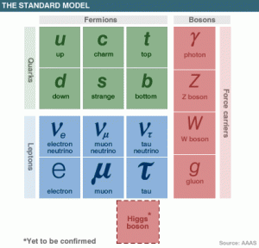
Lepton number:
All leptons have a value of +1. All anti-leptons have a value of -1. Anti-leptons are signified by having the same symbol as a lepton, but with a horizontal bar across the top. All non-leptons have a value of 0. We can use the table below (borrowed from Arne Luker and possibly AAAS) to determine which particles are leptons and would therefore have a value of +1.

Charge & Rest Mass:
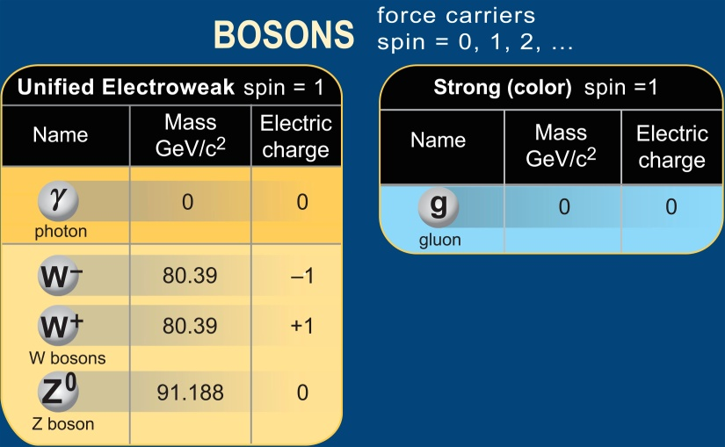
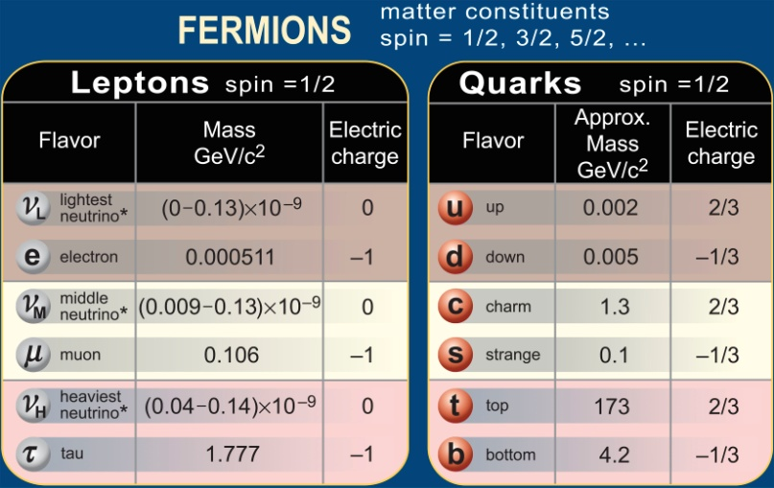
The Standard Model includes the fermions (quarks and leptons) listed above, their antimatter pairs, and the Bosons listed above. The charge & rest mass (or rest energy) of the Standard Model particles is listed in the table below. The table is courtesy of the Contemporary Physics Education Project.
0

